Each of us has only one true calling - to find the path to ourselves. Hermann Hesse

- If you find yourself in a difficult situation, do not isolate yourself, because in this case the problem will seem even more serious and global.
- Find the strength to ask for help, although at first it may seem very scary and difficult.
- Do not panic under any circumstances, because panic brings nothing but loss of strength and energy.
- Look for people who can help you. Even if you have not received support from your closest and dearest people, this does not mean that you will not receive it at all. After all, there are people around us who can and want to help us. Trust them!
- Remember that you are not alone. Your future depends only on you. Everything is in your hands.

A journey of a thousand miles
starts with the first step.
Lao Tzu

If you need help:

Psychologists
EE «GSU named after. F. Skorina»
(8 building, room 44, tel. 33-31-22)

Social educators
EE "GSU named after. F. Skorina"
(4 building, room 1-8, tel. 51-00-82)

Legal clinic of the educational institution “GSU named after. F. Skorina"
(Academic building No. 2, room 1-8, Thu. 14.00 to 16:00,
tel.51-02-97)

City Center for Social Services for Family and Children
(psychological, legal consultations)
(Yubileinaya str., 8, building 2, tel. 35-75-65,
tel.170)

- Health Center (Irininskaya St., 23, tel. 74-77-64)

Emergency psychological assistance
(tel. 31-51-61)

- Youth Health Center “Yunost”, branch No. 3 of the Gomel Central City Children’s Clinical Clinic
- (Bykhovskaya st., 108, room 109, tel. 40-18-98)

telephone numbers of the Teenager Friendly Center, “Teenager” of the Gomel Central City Children’s Clinical Clinic
(Mazurova St., 10в, 31-08-86, 31-08-87,
+375(44) 767-78-27)

Republican Center for Psychological Assistance
(Phone: 8 017 300-10-06 Address: 3 Churlionisa str., Minsk, Minsk region)
Join us!
Educational institution «Gomel State University"
named after Francysk Skaryna»

I see you …

Life is meetings, separations, partings, love, disappointment, misunderstanding, betrayal, desires, dreams, obstacles …

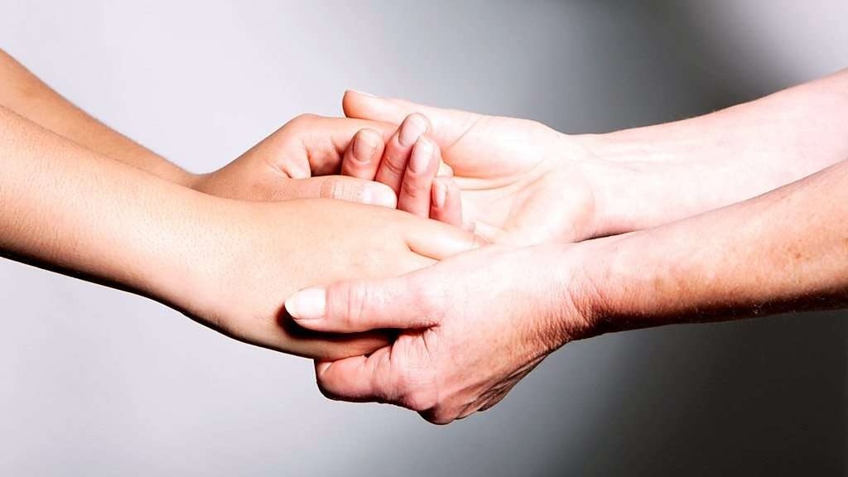

Every person faces difficult life situations and overcomes them in one way or another, sometimes relying on the support of loved ones, sometimes trying to find a way out on their own.

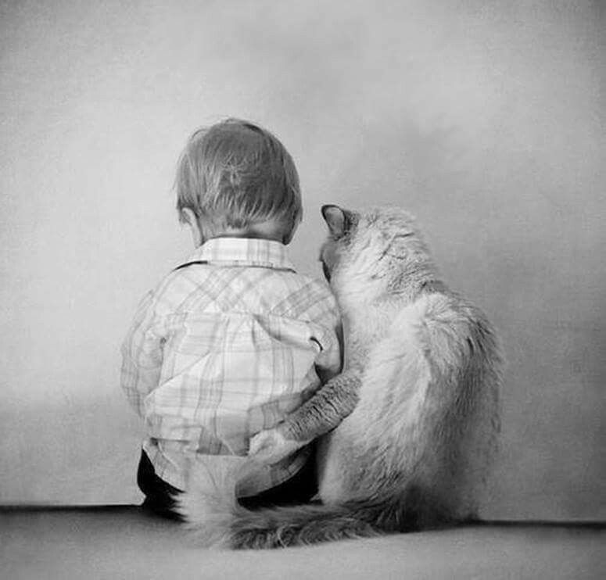

Cases that require professional
psychological assistance:
- If a person is unable to independently cope with intense feelings or bodily sensations, if he feels that the intensity of his emotions does not decrease within a month.
- If, a month after the event, the person continues to feel numb, empty, or similar feelings, if he maintains activity only in order not to remember the events that happened.
- If nightmares and insomnia continue.
- If a person has no one to discuss what happened with, share feelings.
- If family relationships have deteriorated or sexual problems have appeared.
- If a person constantly has accidents, accidents.
- If he continues to smoke, drink, take medications in the same quantities as immediately after the event.
If a person has become worse at coping with his professional responsibilities.

Every person can emerge from a crisis even stronger, wiser and more mature than before. For this it is necessary:
- State your feelings. Show your emotions and discuss them with your loved ones.
- Talk about what happened. Review your experiences alone or with others.
- Keep in mind that memories will not go away on their own. The feelings will remain and will return for a long time.
- Remember that people close to you may experience similar feelings towards you.
- Make time for sleep, relaxation, reflection with your family and close friends.
- Express your desires directly; speak clearly and honestly about them.
- Maintain a normal routine as much as possible.
- Allow your children to talk about their emotions and express themselves through games and drawings.
- Maintain children’s normal routine of life and study and allow them to act according to their own ideas.

